Maintenance Manager
Release Notes v4.5.0.0

Contents

1 Document Control 3
1.1 Author 3
1.2 Document Summary 3
1.3 Document History 3
1.4 Reference documents 3
1.5 Distribution 3
1.1 Quality Assurance 3
2 Introduction 4
2.1 Pre-Requisites 4
3 Functional Changes 5
3.1 Work Order Percentage Uplift Items(Enhancement) 5
3.2 Payment Approval form MAI3856 (Enhancement) 17
3.3 CIM Automation process after FTP failures (Enhancement) 20
4 Log No. Summary 21

- Document Control
  - Author
Exor Development

  - Document Summary
This document provides information about functional changes and a list of all logs fixed in this release.

  - Document History

Document History
Revision | Date | By | Description
1.0 | 26-SEP-2011 | Exor Development |  | First Edition

  - Reference documents
None

  - Distribution
Exor Customers, Partners and Staff

  - Quality Assurance
Document Details
File | Prepared By
Maintenance Manager at v4.5.0.0 | Exor Development
Document Name | Reviewed By
Maintenance Manager at v4.5.0.0 | Mark Lowe
Version | Approved for issue by
1.0 | Colin Stewart
Date of Issue | Support Manager
25-NOV-2011 | Graham Anns

- Introduction
This document defines the changes made to the Maintenance Manager product at release v4.5.0.0 plus a list of all logs fixed in this release.

Unlike the “Maintenance Manager Installation/Upgrade Guide”, this document is specifically targeted at the Maintenance Manager end user. Therefore, if the recipient of this document is an IT person please ensure that it is forwarded on to the relevant end user(s).

This document does not comprehensively describe the functionality of the product, or act as a User Guide.

Please note that any data shown in example screenshots does not represent any Customer’s live data; it is test data set up by Exor.

After reading through this document, should you have any further Maintenance Manager training or Consultancy requirements then please contact your Exor account manager.

  - Pre-Requisites

No pre-requisites at this release

- Functional Changes
This section outlines the functional changes made at v4.5.0.0
  - Work Order Percentage Uplift Items(Enhancement)
Maintenance Manager has been enhanced to include the addition of Percentage Uplift Items to Works Orders allowing for the Works Order Line Cost to be uplifted by a specified percentage for certain types of work. The uplift items that can be defined are as follows:

BOQ Percent Uplift

A BOQ percent uplift item can be assigned to a Work Order Line, and will apply to all BOQs added to the Work Order Line that have been flagged as ‘Allow Percentage Item’.

The percentage item may have a value of zero, i.e. there is no additional cost for the repair, or will contain an actual percentage value. For example, a percentage uplift may be required due to the time of day that the work should be carried out.

Work Order Line Percent Uplift

A Work Order Line percent uplift item can be assigned to a Work Order Line to enable Ad Valorem costs (eg. project management, admin overheads etc) to be applied to the cumulative cost of the Work Order Line.

This uplift will be applied to ALL BOQ values, and associated BOQ Percent uplift values assigned to a Work Order Line.

- Percent Uplift Definition

Standard Items – MAI3888

Standard Items form (MAI3888) has been modified to allow for the specification of BOQ and WOL uplift items:

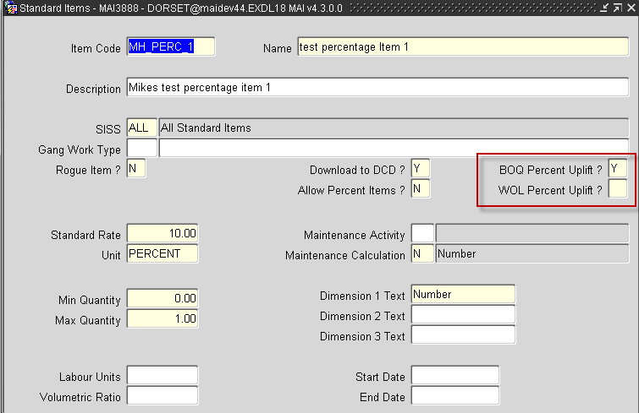.

A value of ‘Y’ in BOQ Percent Uplift ? signifies that the Standard Item can be assigned as a BOQ Percent Item allowing for the percentage uplift rate to be applied to any BOQs on a Work Order Line, where the associated Standard Item will allow for percent items (ie where Allow Percent Items is set to ‘Y’).

A value of ‘Y’ in WOL Percent Uplift ? signifies that the Standard Item can be assigned to the Work Order Line to allow for an Ad Valorem cost to be applied. This uplift value will be applied to all BOQ values, including any BOQ uplift values defined.

Validation will ensure that if a Standard Item has BOQ Percent Uplift or WOL Percent Uplift set to ‘Y’, the user will be prevented from updating to ‘N’ if the Standard Item has been assigned as an Uplift Percent Item on a Work Order.

- Permit Uplift Assignment

Contracts – MAI3880

Contracts form (MAI3880) has been modified to include Allow Percent Uplift and Include in CIM indicators.

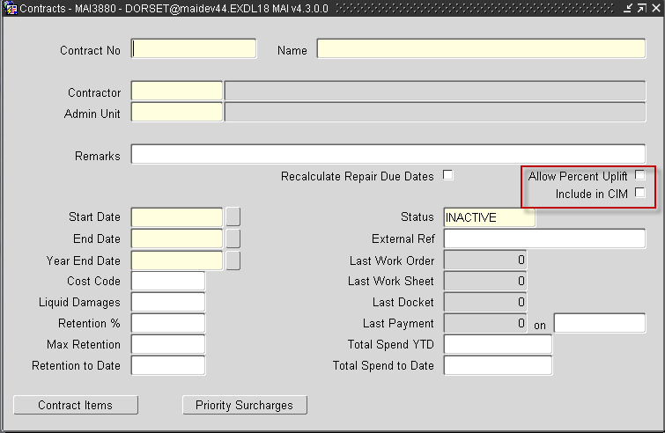

The usage of these indicators can be described as follows

Allow Percent Uplift

Where a Contract Item has been added to the contract, which will allow for percentage uplift calculations for a BOQ/Work Order Line, the percentage uplift will only be applied where the Allow Percent Uplift checkbox has been ticked

Include in CIM

If Include in CIM is selected, the CIM Work Order Extract file will include the BOQ and Work Oder Line Percent Uplift Item code details. If not, the file format will remain as it currently is, with the Percentage Uplift items excluded.
- Work Order Assignment

Works Order - MAI3800

Works Order form (MAI3800) has been modified to include BOQ Uplift Item and WOL Uplift Item fields on the BOQ Items Screen, allowing for the specification of percentage uplift Standard Item Codes to the Work Order Line. These fields will only be enabled if the Contract assigned to the Work Order will allow for percentage uplift items to be assigned ( ie where the BOQ Percent Uplift, or WOL Percent Uplift indicators have been set to ‘Y’)

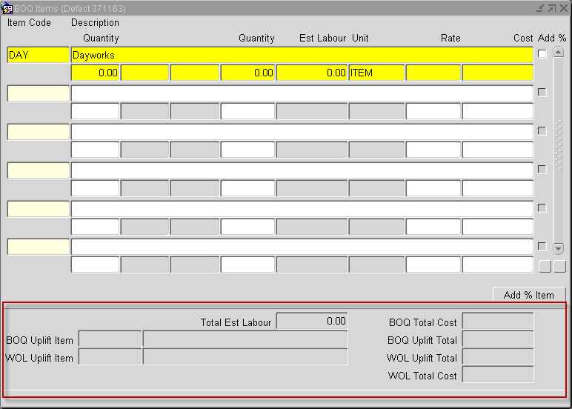

The Standard Item rate, defined for the BOQ Uplift Item, will be applied to any BOQs on the Work Order Line where the Standard Item allows for Percent Items (ie where Allow Percent Item is set to ‘Y’);

The Standard Item rate, defined for the WOL Uplift Item will be applied to all BOQs on the Work Order Line, and will be applied to the total, after any BOQ Uplift values have been applied.

The BOQ Items screen will also be modified to include BOQ Total Cost, BOQ Uplift total, WOL Uplift Total and WOL Total Cost fields, which can be described as follows:

BOQ Total Cost : | Sum of all BOQ Cost values
BOQ Uplift Total: | Result of applying the percentage rate defined for any BOQ Uplift Item assigned to the Work Order Line, to any BOQs on the Work Order Line where the associated Item Code allows for Percentage Uplifts.
WOL Uplift Total: | Result of applying the percentage rate defined for any WOL Uplift Item assigned to the Work Order Line, to the sum of BOQ Total Cost and BOQ Uplift Total.
WOL Total Cost: | Sum of BOQ Total Cost, BOQ Uplift Total and WOL Uplift Total. This value will be displayed in the Est Cost field in the Defects Screen, and will be the estimated cost value used in budget calculations.
.
When a Repair, having Percent Uplift Item Codes assigned, is added to a Work Order, a check is made against the Contract to determine if the Standard Item Code has been assigned as a Contract Item, and that the contract will allow for Percentage Uplifts. If not, the user will be prevented from saving, or Instructing, the Work Order.

When attempting a change of contract, if the current contract allows for Percentage Uplift calculations, and the new contract does not, if Percentage Uplift Item Codes have been defined, the user will be prevented from changing contracts. An appropriate error message will be displayed.

Once a Work Order is instructed, the user will be prevented from modifying the BOQ or WOL Percent Uplift item codes.

- Repair Assignment

Locator Create Defects - MAI3807

Locator Create Defects form (MAI3807) has been modified to include two new fields BOQ Uplift Item and WOL Uplift Item, allowing for the assignment of Percentage Uplift Standard Item codes to a repair.

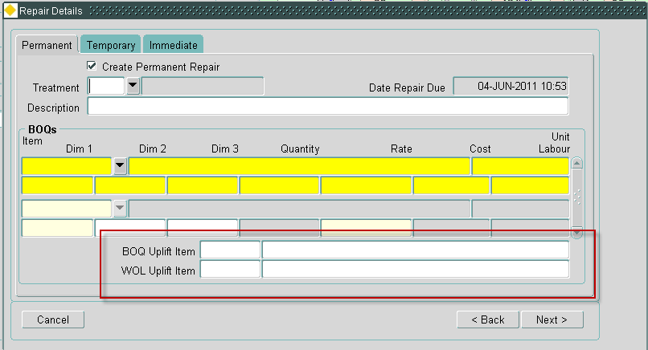

These fields will be available for Permanent and Temporary repairs, but will not appear on the Immediate Tab.

When the Repair is added to a Work Order Line, the BOQ and WOL uplift item codes will allow for percentage uplift values to be applied to BOQ and Work Order values, as described in MAI3800, above.

Inspections - MAI3808

As with Locator Create Defects form (MAI3807), Inspections form (MAI3808) has been modified to include two new fields BOQ Uplift Item and WOL Uplift Item, allowing for the assignment of Percentage Uplift Standard Item codes to a repair. Processing of these fields will mirror that defined for MAI3807.

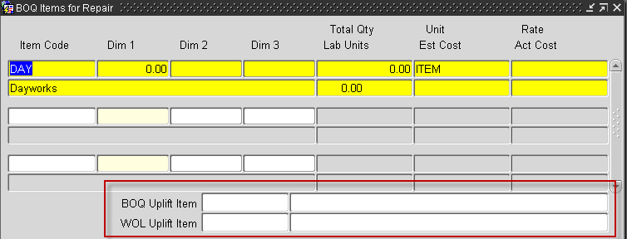..

Maintenance Inspection Summary/Error Correction – MAI4405

Maintenance Inspection Summary/Error Correction form (MAI4405) has been modified to include two new fields BOQ Uplift Item and WOL Uplift Item, allowing for the assignment of Percentage Uplift Standard Item codes to a repair.

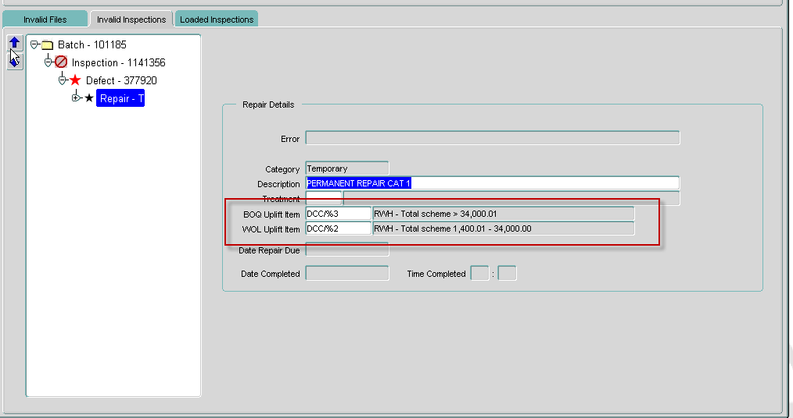

These fields will be available for Permanent and Temporary repairs, but will not be present for immediate repairs.
.

- Percent Uplift Display

Maintain Work Orders - Contractor Interface – MAI3802

Maintain Work Orders - Contractor Interface form (MAI3802) has been modified to include two new fields BOQ Uplift Item and WOL Uplift Item, which will detail Percentage Uplift Standard Item codes that have been defined for a Work Order Line. These fields will be display only, and will not allow modification.

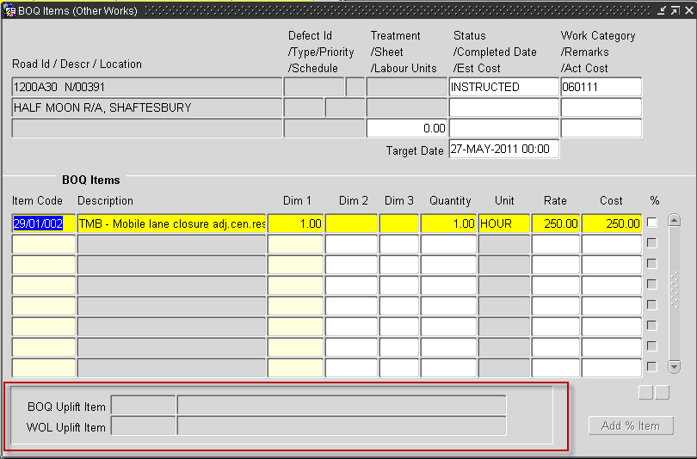

Defects – MAI3806

Defects form (MAI3806) has been modified to display any BOQ / WOL Uplift Item codes defined for a repair.

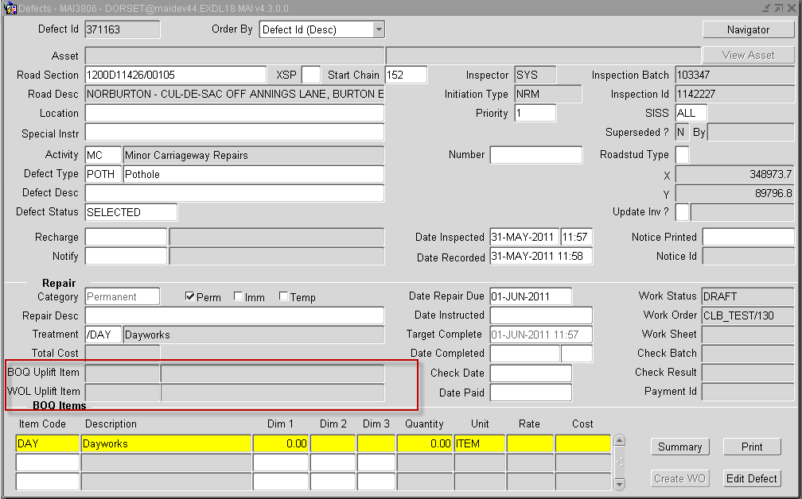

- CIM File Modification

The CIM Works Order file format has been enhanced to include BOQ, and Work Order Line, Percentage Uplift Item Code details.

The inclusion of these details will be controlled by an indicator added to the Contracts form (MAI3880), detailed above, allowing for current file formats to be used where the percentage uplift values cannot be processed by the external Contractor systems.

Percentage Uplift rates will be applied during processing of the CIM Invoice File and will be used to calculate the Estimated, and Actual values, on the work orders. These values will then be used in budget calculations

CIM File Format Changes
CIM Works Order File contains additional fields BOQ percentage uplift Standard Item Code, BOQ percentage uplift Standard Item Name, WOL percentage uplift Standard Item Code and WOL percentage uplift Standard Item Name in the Work Order Line (Record Type 10) record type.

Works Order File - Work Order Line
Field | Data type | Description
Record Type | Varchar2(2) | Contains ‘10’
Work Order Line Number | Number(8)
Defect Id | Number(8)
Cyclic Schedule Id | Number(9)
Road Id | Varchar2(20)
Road Description | Varchar2(80)
Defect Location | Varchar2(1000)
Defect Description | Varchar2(254)
Defect Special Instructions | Varchar2(254)
Defect Priority | Varchar2(4)
Defect Type | Varchar2(4)
Defect Chainage | Number(6)
XSP | Varchar2(1)
% Adjustment – Reserved for future use | Number(4,2)
% Adjustment reason code – Reserved for future use | Number (2)
Work Category | Varchar2(10)
External Cost Code | Varchar2(60)
Defect Activity | Varchar2(2)
Defect Asset Type | Varchar2(2)
Defect Asset Id | Number(8)
Defect Date Inspected | Date | Format DDMMMYYYY
Repair Category | Varchar2(1)
Repair Description | Varchar2(40)
Repair Treatment | Varchar2(4)
Date Repair Due | Date | Format DDMMMYYYY
Easting | Number
Northing | Number
BOQ percentage uplift Standard Item Code | Varchar2(10) | Specification of Standard Item Code which defines the percentage uplift rate to apply to the BOQ value
BOQ percentage uplift Standard Item Name | Varchar2(254) | Standard Item Name defined for the BOQ percentage uplift Standard Item Code
WOL percentage uplift Standard Item Code | Varchar2(10) | Specification of Standard Item Code which defines the percentage uplift rate to apply to the Work Order Line value
WOL percentage uplift Standard Item Name | Varchar2(254) | Standard Item Name defined for the WOL percentage uplift Standard Item Code

- EDIF File Modification

The EDIF file, for Mapcapture, has been enhanced to include the BOQ and Work Order Line percentage uplift indicators defined for the Standard Items records, as specified in the EDIF File modifications, below.

EDIF File Format Changes
EDIF file Record Type 34, defining Standard Item Details, will contain additional fields BOQ Percentage Uplift and WOL Percentage Uplift.

Record Type 34
Field | Data type | Description
Record Type | Varchar2(2) | Contains ‘34’
Standard Item Sub Section (SISS) Code | Varchar2(3)
Item Code | Varchar2(10)
Item Name | Varchar2(254)
Unit | Varchar2(8)
Minimum Quantity | Number(10,2)
Maximum Quantity | Number(10,2)
Dimension 1 | Varchar2(12)
Dimension 2 | Varchar2(12)
Dimension 3 | Varchar2(12)
BOQ Percentage Uplift | Varchar2(1) | ‘Y’ Indicates that the Standard Item can be assigned as a BOQ percentage uplift item. Otherwise the value will be ‘N’
WOL Percentage Uplift | Varchar2(1) | ‘Y’ Indicates that the Standard Item can be assigned as a Work Order Line percentage uplift item. Otherwise the value will be ‘N’

- Mapcapture

Mapcapture has been modified to allow for the assignment of the BOQ and WOL Uplift Items to a Repair, as shown below:

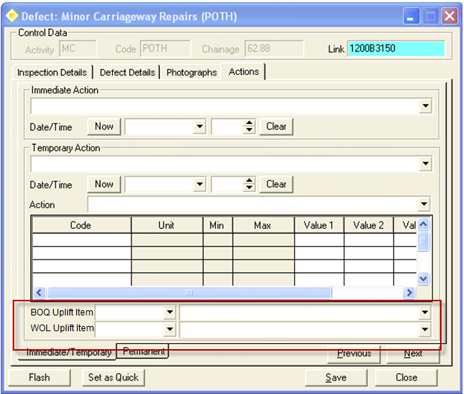

Any BOQ, or WOL, Uplift Percent items will be included in the Inspection Load File, as defined in the Inspection Loader file changes defined below.

Inspection Loader File Format Changes
Inspection Loader Temporary and Permanent repair record types will contain additional fields BOQ percentage uplift Standard Item Code and WOL percentage uplift Standard Item Code

‘L’ - Temporary Action Details
Field | Data type | Description
Record Type | Varchar2(1) | Contains ‘L’
Repair Description | Varchar2(240)
Date Repaired | Date | YYMMDD Format
Time Repaired | Date | HHMM Format
Treatment | Varchar2(4)
BOQ percentage uplift Standard Item Code | Varchar2(10) | Specification of Standard Item Code which defines the percentage uplift rate to apply to the BOQ value
WOL percentage uplift Standard Item Code | Varchar2(10) | Specification of Standard Item Code which defines the percentage uplift rate to apply to the Work Order Line value

‘M’ – Permanent Category 1 Action Details
Field | Data type | Description
Record Type | Varchar2(1) | Contains ‘M’
Repair Description | Varchar2(240)
Date Repaired | Date | YYMMDD Format
Time Repaired | Date | HHMM Format
Treatment | Varchar2(4)
BOQ percentage uplift Standard Item Code | Varchar2(10) | Specification of Standard Item Code which defines the percentage uplift rate to apply to the BOQ value
WOL percentage uplift Standard Item Code | Varchar2(10) | Specification of Standard Item Code which defines the percentage uplift rate to apply to the Work Order Line value

‘N’ - Permanent Category 2 Action Details
Field | Data type | Description
Record Type | Varchar2(1) | Contains ‘N’
Repair Description | Varchar2(240)
Treatment | Varchar2(4)
Sub Category | Integer | Not used in EID Format files
BOQ percentage uplift Standard Item Code | Varchar2(10) | Specification of Standard Item Code which defines the percentage uplift rate to apply to the BOQ value
WOL percentage uplift Standard Item Code | Varchar2(10) | Specification of Standard Item Code which defines the percentage uplift rate to apply to the Work Order Line value

- Inspection Loader File Modification

The inspection Loader module has been modified to process any values defined for Record Types ‘L’, ‘M’ or ‘N’, as described above, assigning them to any Repairs created. Where Works Orders are automatically created, the % Uplift details will be applied to the Work Order Lines created.

In the Automatic Work Order creation, where the Standard Item Code assigned to a repair does not exist as a Contract Item for the Contract assigned to the Work Order, the repair will be added to the work order, but the work order will not allow for Instruction. If the Work Order Automation Rules specify that the work orders should be automatically instructed, a message will be produced indicating the failure to instruct. The same would apply if the Contract does not allow for Percent Uplift calculations.

- IMF View Changes

Modifications have been made to IMF views to include the BOQ and WOL Uplift Item Codes to allow for enhancement to the Work Order Worktray:

  - Payment Approval form MAI3856 (Enhancement)
The Payment Approval form (MAI3856) has been enhanced to include additional detail, and functionality, to help users make informed decisions when carrying out the approval process.
A brief summary of the changes is as follows:
- Additional fields have been added to the Work Order Lines tab, these include
  - Road Description
  - Work Order Originator details
  - Work Order Authoriser Details
  - Original Estimate of the work
  - The percentage difference between the estimate and total value of the work.
- When querying data, the form will initially be restricted to current data by default, with an option to view all data.
- When entering a query in the either the Invoices or Work Order Lines tab, the query will apply to both tabs. For example, if the query is restricted to display details for a Work Order in one of the tabs, both tabs will be restricted to display details for that Work Order.
- Both the Invoices and Work Order Lines tabs have been modified to include ‘Order By’ buttons at the top of the main column details, allowing for data returned to be ordered by the column where the button has been pressed.
- A Navigator button has been included in both tabs to allow for the Navigator module to be called, displaying details for the currently selected Work Order.
- Screen Changes

Additional Fields
Fields have been added to the Work Order Lines tab to give the user more information, but with minimum changes to the layout of the form.
The Road Description field has been added next to the Road Id fields as shown below: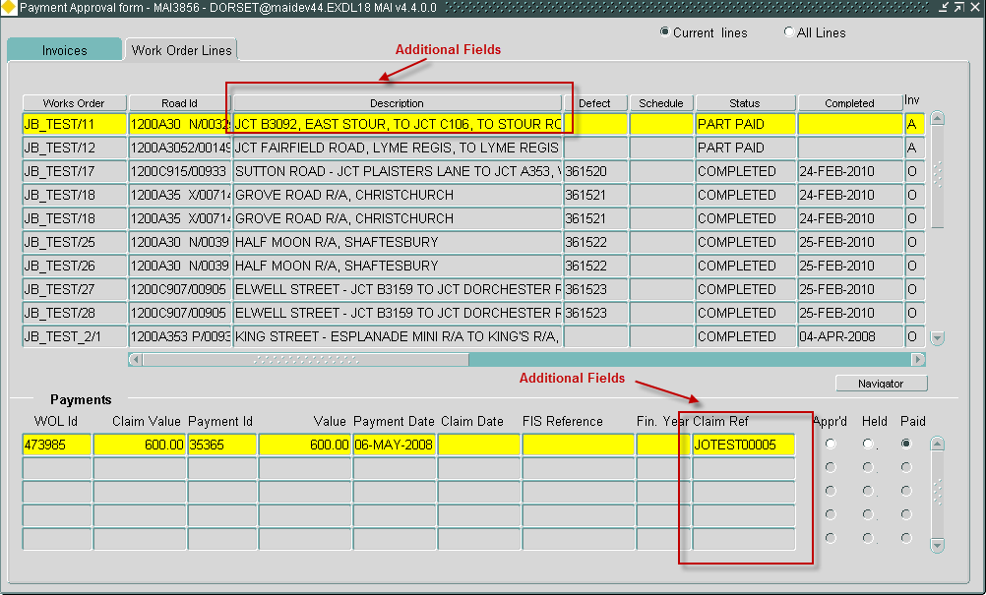
The Claim Ref. Field has also been added to the Payments panel.
A scroll bar has been added to accommodate the remainder of the user and cost information, with the Work Order column remaining anchored for context, when scrolling through the additional details.
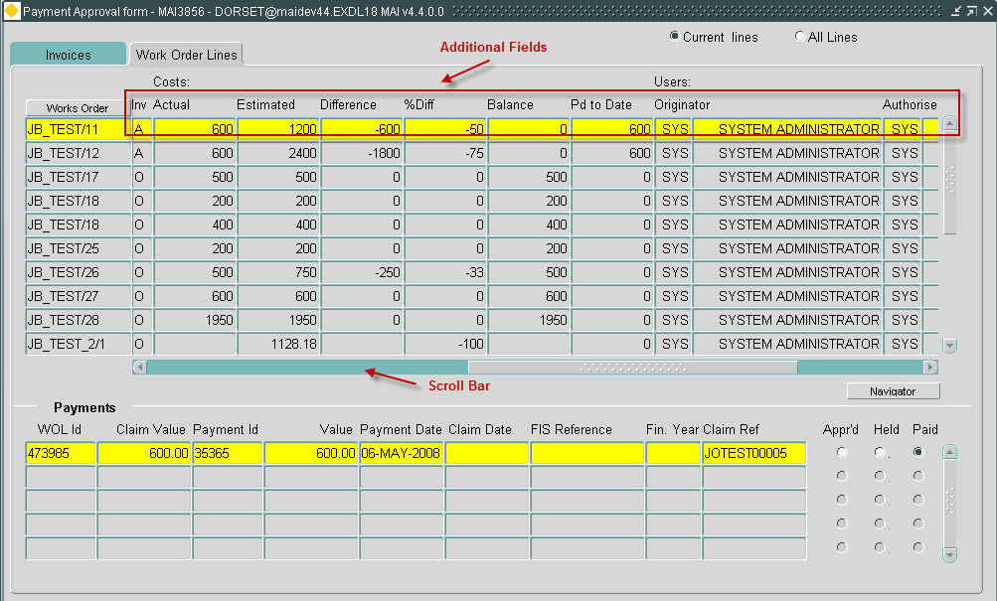
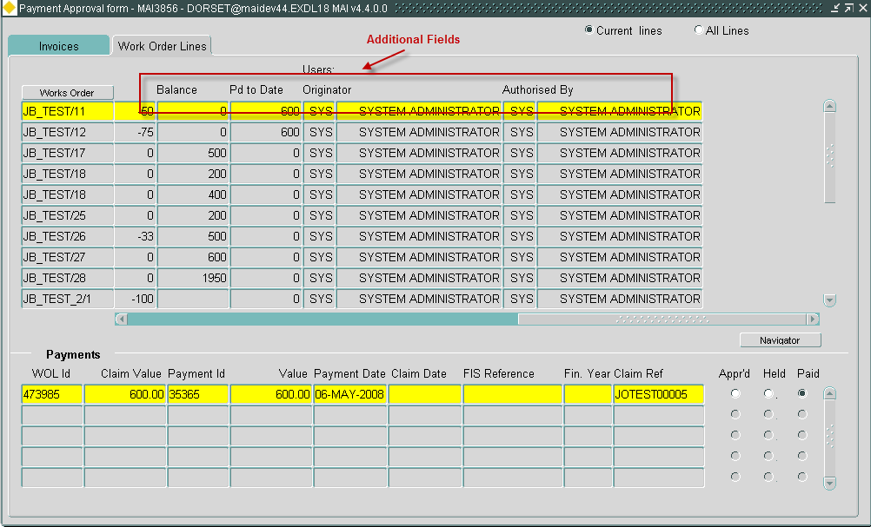
Data Retrieved
Two radio buttons have been introduced, one to display all data and one to display current data i.e. excluding works that have been ‘Paid’ or superseded and ‘Held’.

The radio buttons will apply to both the Invoices and Work Order Lines tabs.

Querying Data
When a query is entered into either the Invoices or Work Order Lines tabs, both tabs will be synchronised to contain the appropriate data in each tab relating to the query entered.

Ordering Data
Once some data has been queried back into the form the user may select the ‘Order By’ buttons at the top of each column to order the data either ascending or descending within the column.
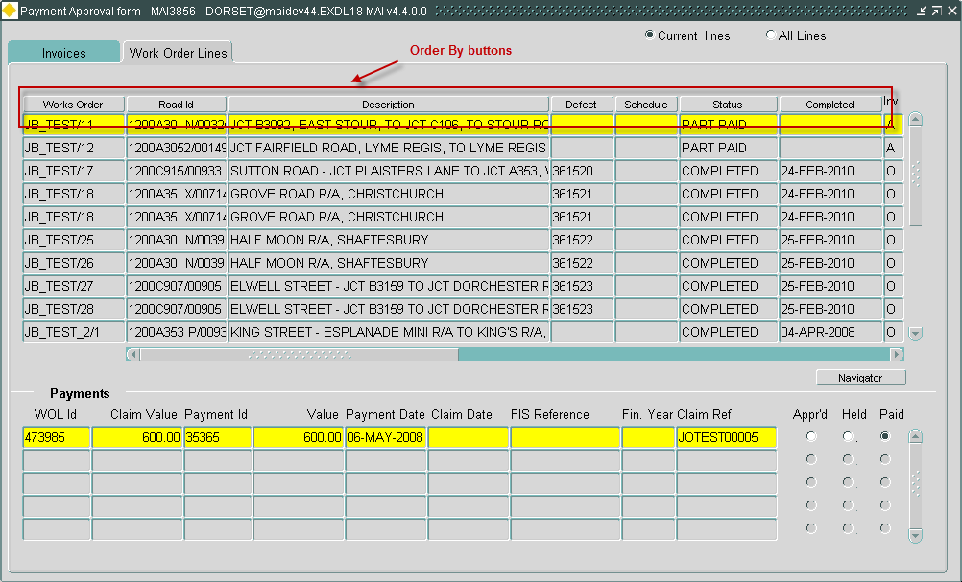
Navigator
The Navigator button
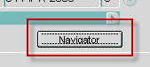
has been added to the form, to display the Work Order Line, and all associated data providing the user has the appropriate permissions. For example:

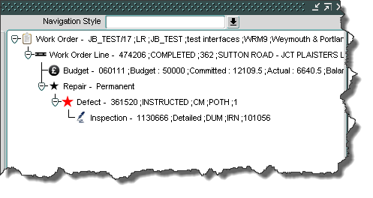

  - CIM Automation process after FTP failures (Enhancement)
When Processing CIM Work Order Extract files, if FTP configuration has been specified the output files produced are created on the Database Sever and transferred to the location specified in the FTP configuration. If the FTP fails, the files will remain on the Database Server. Any subsequent processing of the CIM Work Order Extract will not attempt to re-transfer these files.

CIM Automation has been modified to identify any CIM Work Order extract files on the Database Server that have failed previous FTP transfers. The process will attempt to re-transfer any found, along with any files produced from the current process. Log entries will be written to the Process Monitor log, as shown in the following example:

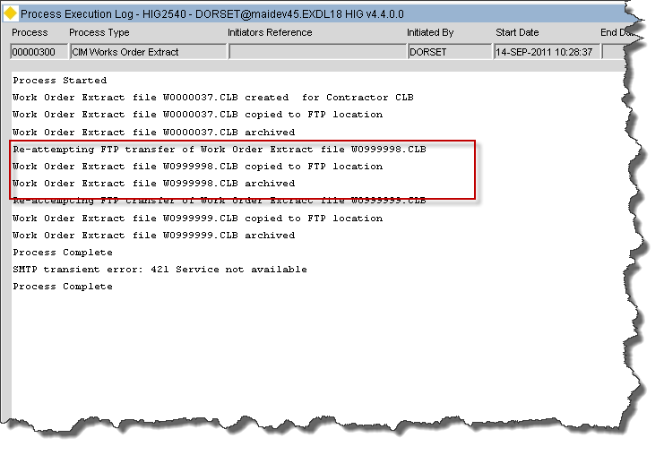

  - Product Option UPDWOTGT
When the product option UPDWOTGT is set to ‘Y’ the Work Order Target date in MAI3800 will not be automatically calculated, based on the Work Order Line target dates and Work Order Priority, but will allow for manual specification.

The Work Order Target date will only be populated if a Work Order Priority is entered. Otherwise, the value will be NULL requiring population before Authorisation or Instruction.

The product option will be initially set to ‘N’.

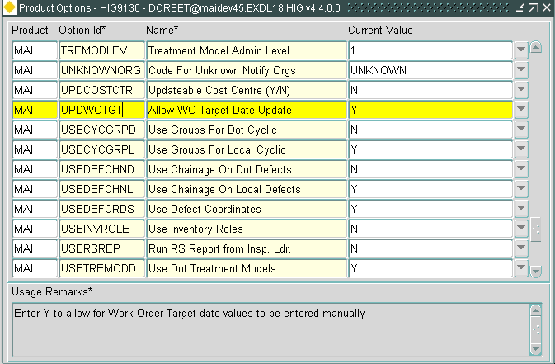

This product option has two values:-

N = Work Order Target date is automatically populated
Y = Work Order target date is not populated, and requires manual specification.
- Log No. Summary
This chapter summarises all Software Changes (enhancements and new functionality) and Bug Fixes that have been made in this release.

These changes are derived from the following sources,

Issues raised by Customers via Exor Support
Issues raised internally by Exor

Internal  Task ID | Issue | Support  Log(s)
0110658 | A number of error messages used by the Maintenance Inspection Loader have been altered to provide a better description of the problem.
0111095 | The Work Order Automation Rules form (MAI3818) have been modified to ensure end-dated Road Group details in the LOV are not displayed
0111126 | When a CIM invoice file is processed, where discount groups are being used on the Works Order, the calculation of Actual and Estimate values do not always take the discount group values into consideration. The routines have been modified to ensure the correct values are calculated
0111246 | The PED file extract has been modified to only extract the appropriateroad type meta-data for the road id specified. i.e Local or DoT meta-data, depending on the road details, not both | 8001048308
0111354 | Defects form (MAI3806) has been modified to ensure the derivation of the Activity description takes the network type into consideration, resolving the problem where the wrong description is being displayed. | 8001121836
0111370 | The PED file extract, for mapcapture, has been modified to allow for 4 character asset types. Record type 12 details were being omitted, when asset types were > 2 characters | 8001064304
0111372 | In Locator Create Defects form (MAI3807), if the user modifies the Activity, when the Defect Type is populated, the form will allow the Activity to be changed, without clearing the Defect Type. This will allow for details to be saved with invalid Activity/Defect Type combinations. The form has been modified to clear the Defect Type field on change of an Activity | 8001134131
0111477 | When copying a Work Order in Works Order form (MAI3800), the Originator details were being copied, rather than using the details from the person copying the Work Order. The form has been modified to populate the Originator details with those of the person copying | 8001187596

